Task 2: Link Data—Create External Tables to Data Share

1. On the Link Data page **select drop-down list** for Select Cloud Store Location or enter a public URL
2. Select the **LoanApp_Share_Provider**.   
   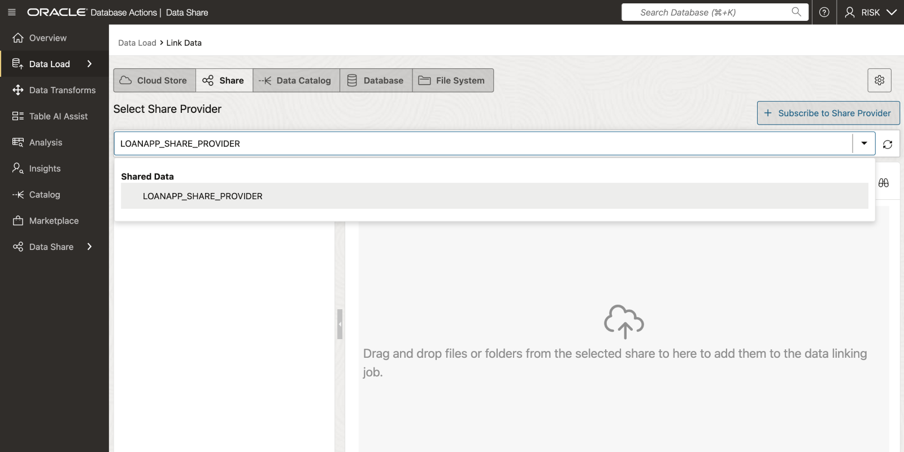

1. Expand the drill down tab for the share named **LoanApp_Share_Provider** to display the available data.
2. Now Let's create an external table based on the **LOAN.Shared_Loan_Data_Risk_VW** file by dragging and dropping this file onto the data linking job section.

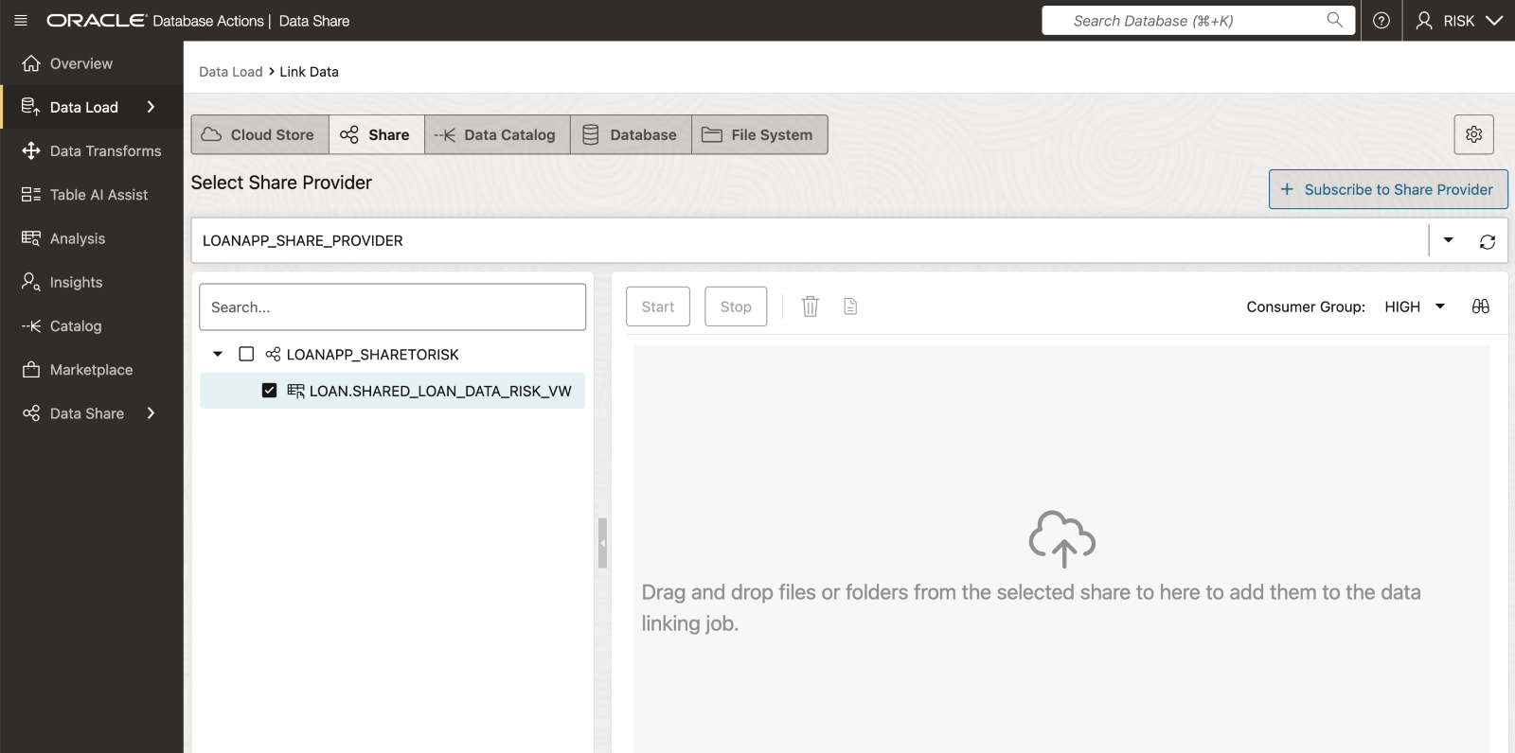   
 

* This causes the external table to be created is displayed in the data linking job section.   
     
  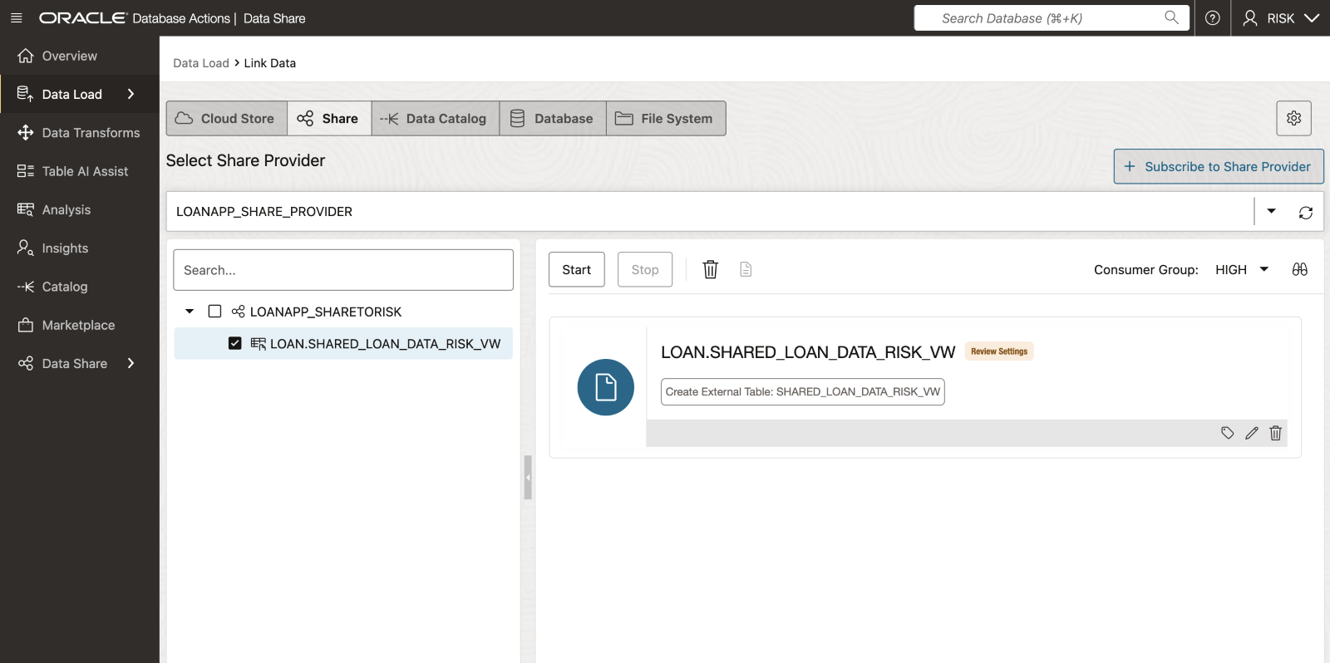

1. Click on the **Settings** (pencil Icon) to display the Link Data from Cloud Store Location panel. You can use the various tabs listed on the left rail to perform actions like change the name of the external table name to be created, view the table's properties, view the table's data, view the SQL code used to create the table and more.

* Edit Table Name to be **Shared_Loan_Data_Risk**

   
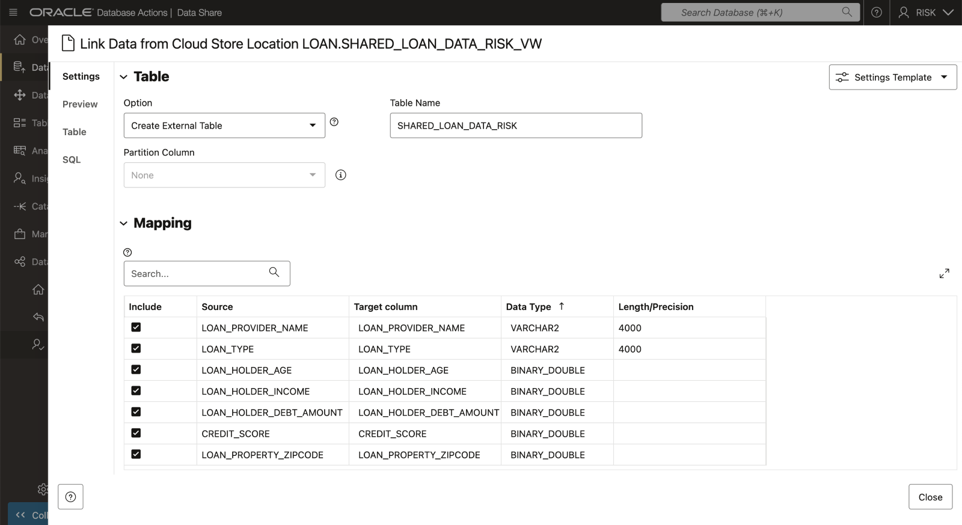 

* Click **Close** to proceed

1. Click **Start**
2. On the popup box that appears click **Run**..   
      
   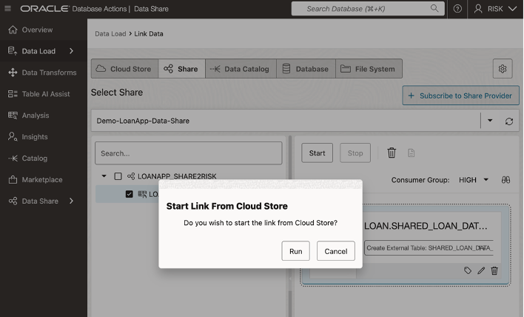
3. After the link job is completed, make sure that the data link card has the link icon next to it.   
      
   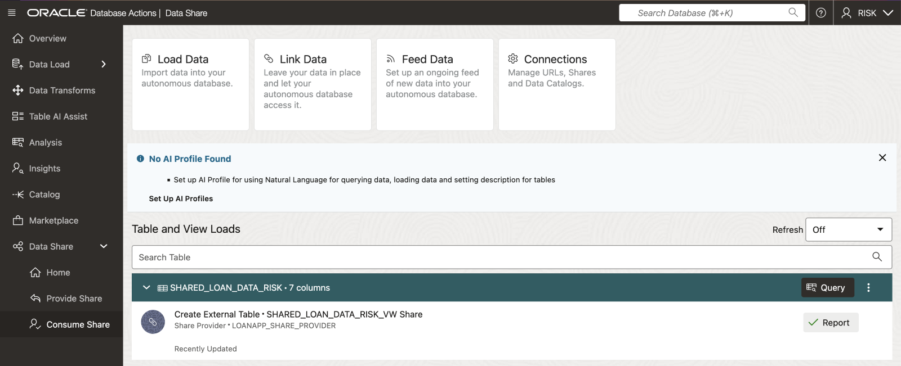

Task 3: Validate ADB Access to Object Storage Data

1. Click the **Report** button for this link job to view a report of the total rows processed successfully and failed for the selected table and the SQL used.

Click **Close** when done.   
   
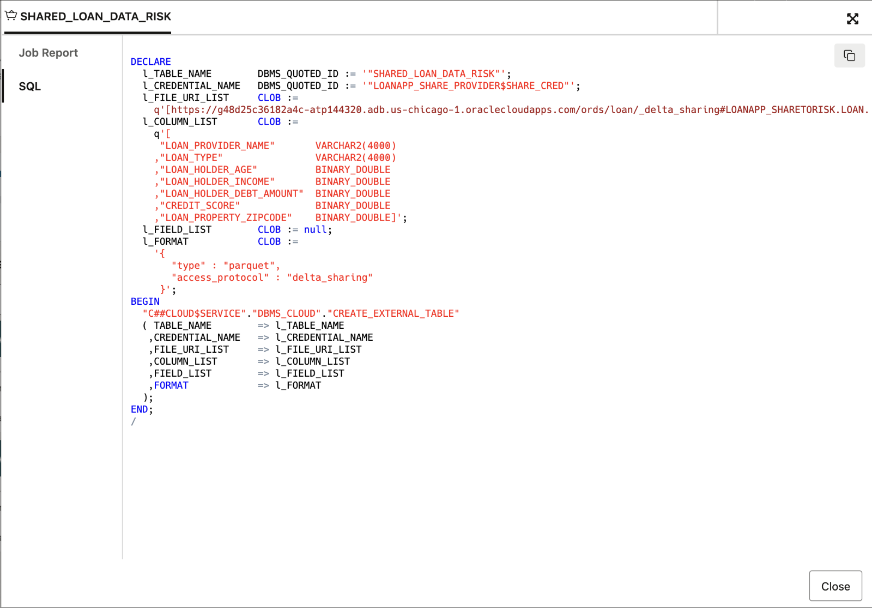 

    2.  In the **Table and View Loads** section:

* Click the external table link named **Shared_Loan_Data_Risk** to preview its data.

Remember, that the source data for this external table is from the **Shared_Loan_Data_Risk_VW** data share.

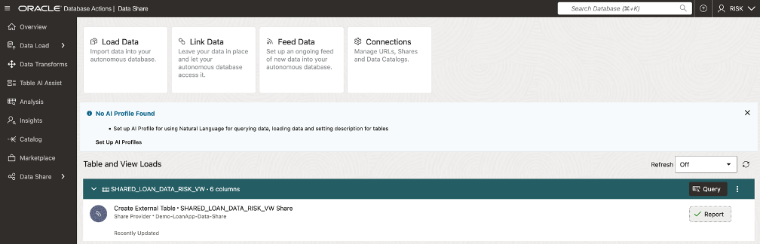   
   
The  **Shared_Loan_Data_Risk_VW**  panel is displayed with the **Preview** tab selected by default that displays the external table's data.

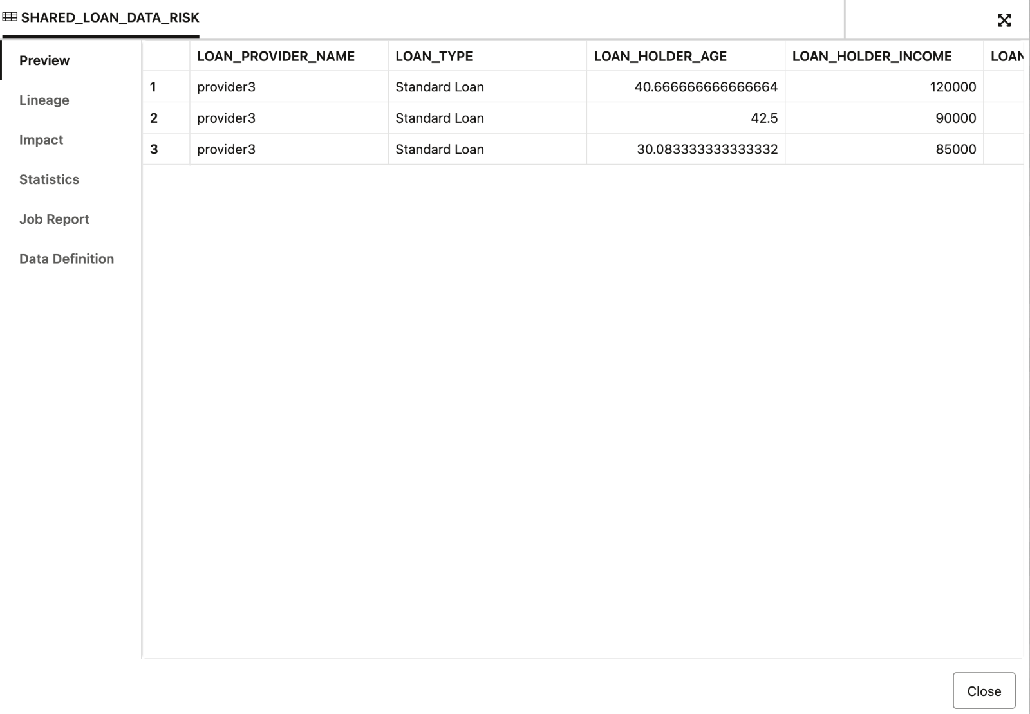

1. Click **Close** to exit the panel and to return to the Data Share Dashboard.
2. Click on **Query** button to run a query from ADB against the Linked Shared Data

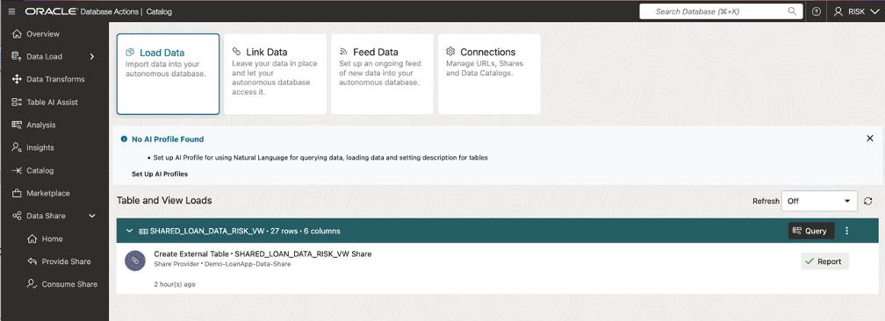

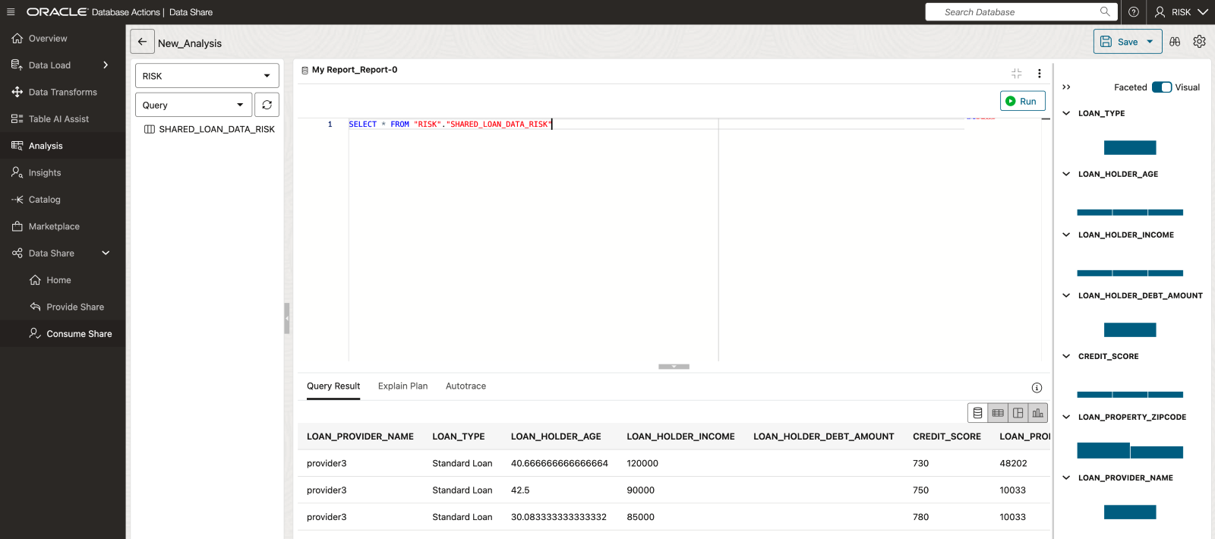

**Congratulations you have now subscribed to the data shared with you from ADB via Data Share and confirmed you can query the data.**